The Developing Excellence in Leadership, Training and Science (DELTAS​) Africa Initiative

**About DELTAS Africa**

DELTAS Africa is a five-year (2015-2020) programme being implemented by the African Academy of Sciences’ Alliance for Accelerating Excellence in Science (AESA) with the support of the Wellcome Trust and the UK’s Department for International Development to train and develop world class researchers and research leaders in Africa.

**Vision:**

The vision of DELTAS Africa is to support the Africa-led development of world-class researchers and research leaders in Africa. This new generation of scientists will play a major part in shaping and driving a locally relevant health research agenda in Africa, contributing to improved health and development on the continent.

To achieve its vision, DELTAS Africa funds programmes that address four strategic areas:

* scientific quality,
* research training
* scientific citizenship
* research management and environment

These strategic areas are recognised as necessary for strengthening, sustaining, attracting and retaining excellence in research.

**DELTAS Africa objectives**

DELTAS Africa seeks to:

• Produce world-class scientific research to address African health and research priorities.

• Support the training of scientists and enable the development of careers in scientific research help them develop their careers.

• Nurture mentorship, leadership and equitable collaboration in science, and engagement with public and policy stakeholders.

• Cultivate professional environments to manage and support scientific research.

**DELTAS Africa grant holders in Africa**

Nearly US$100 million has been awarded to 11 leading African researchers to implement cutting edge collaborative research and training programmes across the continent.

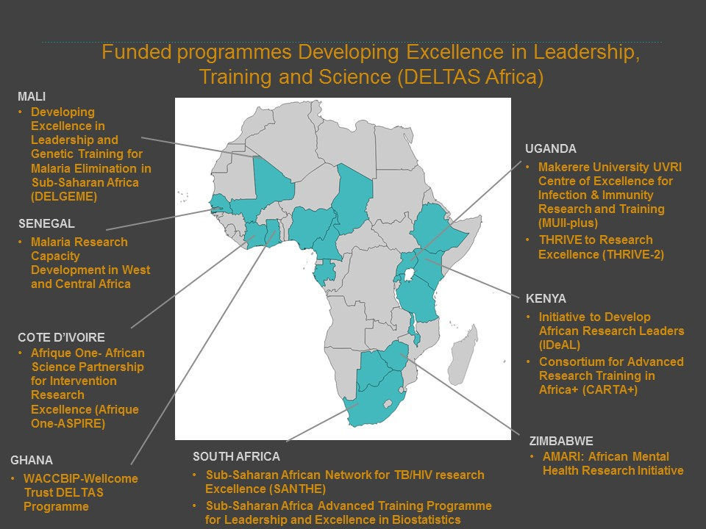

All DELTAS programmes have collaborations between themselves and other African and European institutions, and aim at improving research capacities in various disciplines.

|  |  |
| --- | --- |
| Programme | Programme Focus |
| Afrique-One | Research and training in animal - human - environment interface |
| AMARI | Mental, neurological and substance use disorders research |
| Biostats | training for masters and PhD students across Africa in biostatistics |
| CARTA+ | Doctoral and postdoctoral training in public and population health research |
| DELGEME | Doctoral and post-doctoral training in genomics and bioinformatics across Africa. |
| IDeAL | Train and develop outstanding young African scientists into world-class research leaders. |
| MARCAD | Training and early and senior post-doctoral fellowships in research areas pertinent to malaria elimination |
| MUII Plus | Training African research leaders in bioinformatics, immunity and infectious diseases. |
| SANTHE | Develop a network for training HIV and Tuberculosis researchers |
| THRIVE-2 | PhD training and postdoctoral fellowships in infectious diseases or neglected tropical diseases, maternal, neonatal and reproductive health and non-communicable diseases |
| WACCBIP | Postdoctoral, PhD training and to develop a graduate internship programme in pathogen biology and human genetics |

**Projected DELTAS Trainees (2015 – 2020)**

Over a period of five years, DELTAS programmes will train over 1,300 scientists from different cadres across the African continent.

**DELTAS Host Institutions**